SIOUX EMPIRE PRIDE SPORTS ASSOCIATION (SEPSA)
MEETING AGENDA
October 4, 2025

Call to Order (Time: )
Roll Call:
Executive Officers:
- Chris Sorenson, President | - Michael Hanson, Vice-President
- Michael Hanson, Interim Secretary | - Mariah Johnson, Treasurer
- Cari Weddell, Chief Information Officer

Executive Committee Members:
- Marketing Director (Open Position) | - Recruitment Director (Open Position)
- Community Volunteer Director (Open Position) | - Communications Director (Open Position)
- Sponsorship Director (Christopher, Interim)

League Commissioners:
- Kenna Burmeister, Bowling  - Taylor Rasmussen, Asst Commissioner | - Damon Farah, Softball  - Jacob Grimes, Asst Commissioner  - Megan Westra, At Large
- Open Position, Kickball  - Open Position, Asst Commissioner  - Steve McGinn, Pool  - Damon Farah, Asst Commissioner | - Cari Weddell, Volleyball  - Open Position, Asst Commissioner

Team Managers & Visitors:

Order of Agenda:
- League Reports
- Director / Executive Committee Reports
- Standing Committee Reports
- Executive Board Reports
- Announcements & Public Comment (No action can be taken by the board)
- Adjournment
League Reports:
Bowling:
- Informational Items
  - Starts this Sunday 10/5/25
  - Cost is $13/person
  - Shoe rental went up this year to $3
  - End of season tournament is 12/14/25
  - 12 teams registered, 6 free agents
- Board Action Items
  - N/A

Softball:
- Informational Items
  - Now that the portal messaging is up and running we can have softball communication go through iPride App
  - The seasonal schedule needs to get started.
  - Marketing material needs to be started.
  - Summer IPS meeting:
    - Master slide deck from the summer meeting are in the drive
    - Ipride is looking into adding multiple draft tournaments to the organization, softball, golf, kickball, darts
    - Archives are still working on digitizing everything
    - iPride has made their first payout from their student foundation
    - Multiple fines have gone up.
      - $100 fine for missing mandatory Ratings Clinic has gone up to $1000
  - Save the dates ​​
  - 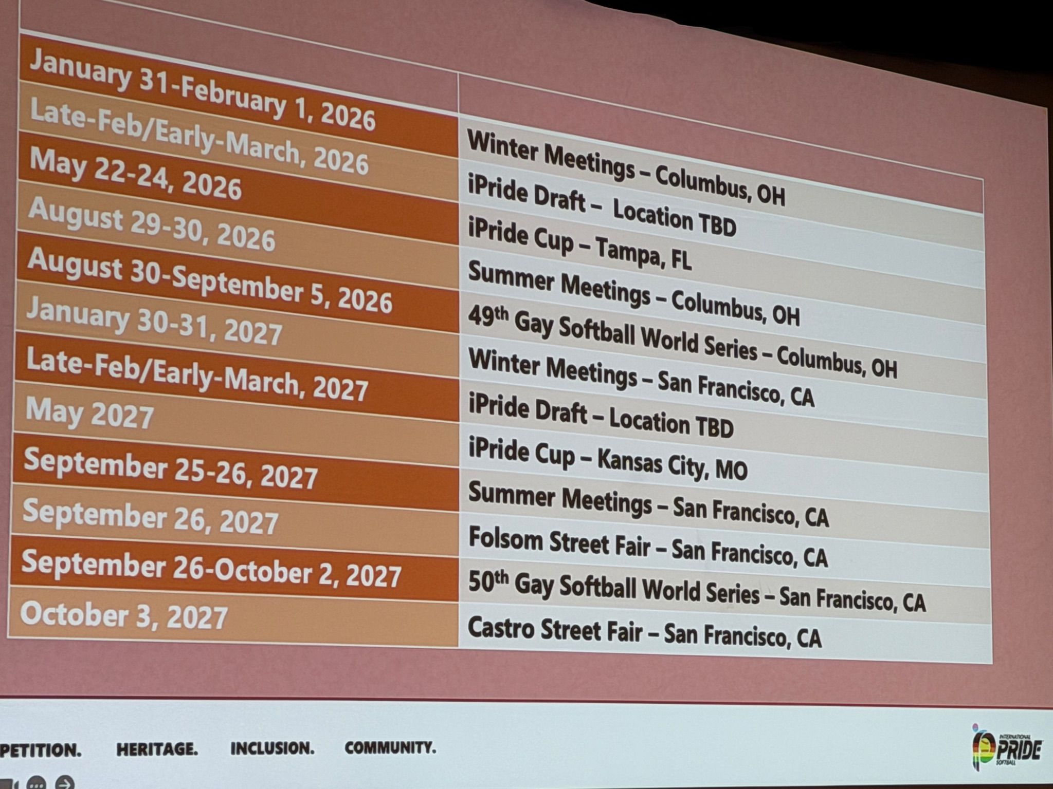
- Board Action Items
  - N/A

KickBall:
- Informational Items
  - Commissioner Position is open
- Board Action Items
  - N/A

Volleyball:
- Informational Items
  - Season has ended, will start making plans for next season. Need to open registration much earlier this year
- Board Action Items
  - N/A
Pool:
- Informational Items
  - First week had some items that needed to be ironed out, but no issues
    - Incident with bartender; member was removed from facility. Commissioners had conversation with management.
  - Registration needs to start earlier next year
  - Dropped from 4 person teams to 2 person teams
  - Looking at moving back to Wednesday
- Board Action Items
  - Treasurer to reimburse the first few captains that paid $50 team fee instead of the $25.

Director Reports
Communications Director Reports:
- Informational Items
  - Is everyone set up with Google email and chat
- Board Action Items
  - N/A

Recruitment Director Reports:
- Informational Items
  - No report
- Board Action Items
  - N/A

Sponsorship Director Reports:
- Informational Items
  - Drag the Fields
    - $2,941 raised for SEPSA
      - 1,500 cash at the door
      - 705 advance ticket sales
      - 120 Zeffy at the door
      - 287 50:50 cash
      - 70 50:50 Zeffy
      - 224 tips donated
      - 45 drink special
  - Promote DIVAS Drag Spectacular Oct 25 at The District
    - Facebook pages are active
    - Board needs to promote
  - Applebee's Fundraiser deposited
    - Just over $150 raised.
  - Starting planning for 2026 events
- Board Action Items
  - N/A

Community Volunteer Director Reports:
- Informational Items
  - No report
- Board Action Items
  - N/A

Marketing Director Reports:
- Informational Items
  - iPride Marketing can assist on creating plans
  - Proper usage of iPride Logo
  - Rand Peterson will to help occasionally design graphic
- Board Action Items
  - N/A

Standing Committee Reports
Sponsorship, Marketing, & Recruitment Committee
- Informational Items
  - Blake Pulse and Cody Holder are interested in starting Pickleball League
  - Softball requested purchase of Pride flags, 10 flags were purchased from Sioux Falls Pride
- Board Action Items
  - Authorize Cody to be Commissioner with Blake as Asst Commissioner of Pickleball League and begin set up of League.
    - Motion: Michael motion to table to Nov. Second: Cari Vote: Unan

Operations / Events Committee
- Informational Items
  - Sioux Empire Classic
    - Promoted Sioux Empire Classic at iPride summer meetings, postcards
    - Anthony (Kansas City), Chris (Twin Cities), and Brad (Memphis) agreed to be advisors
    - Submitted Tournament information to iPride Tournament page
    - iPride Marketing available to assist with marketing campaign
  - All League Event
    - October 4 @ Lucky’s

- Board Action Items
  - N/A

Hall of Fame Committee
- Informational Items
  - No Report
- Board Action Items
  - N/A

Executive Board Reports
President’s Report:
- Informational Items
  - Ways to increase involvement within SEPSA
  - iPride Breakout session, discussion about promoting across other iPride FB pages
Volunteering for iPride, DEI and Marketing
- Board Action Items
  - N/A

Vice President’s Report:
- Informational Items
  - Funds management policy in development
    - Policy & procedure to be reviewed November meeting & voted in December
- Board Action Items
  - N/A

Treasurer's Report:
- Informational Items
  - $100 in cash box
    - Chris took $40 for quarters
    - $60 in cash box currently
    - Chris will paid $40 out of his own money for pool and needs to be reimbursed
  - Reimburse pool captains $25 for those who paid $50
  - Need to get $25 from Damon for Krisztian Fasi and mark as paid in LeagueApps under Fall Pool
    - Sent via Venmo to Treasurer
  - Grievance committee follow up

- Board Action Items
  - Financials will be issued next month after reconciliation.

Chief Information Officer Report:
- Informational Items
  - MFA has not fully been implemented as far as I know, but will happen soon for the Google account.
  - Is anyone still having issues accessing the Google workspace that needs additional assistance?
- Board Action Items
  - N/A

Secretary’s Report:
- Informational Items
  - Presentation from Grievance Committee
    - Need to send communication back to committee to verify their interest
- Board Action Items
  - Motion to approve September minutes
    - Motion: Cari Second: Jacob Vote: Unan

Adjournment:
Motion: Hanson Second: Damon Vote: Unan

Notes & Reminders:
Please submit additions and changes by Thursday before the meeting

Next Meeting: November 8, 2025 | Location: SF Library

Website: www.siouxempirepsa.org  Registration: www.siouxempirepsa.leageapps.com | MAILING ADDRESS  PO BOX 88657  SIOUX FALLS, SD 57109
Email: info  Google Drive: admin | “PHYSICAL” ADDRESS  2501 S LOUISE AVE UNIT 88657  SIOUX FALLS, SD 57109

