SIOUX EMPIRE PRIDE SPORTS ASSOCIATION (SEPSA)
MEETING AGENDA
(06/06/2026)

Call to Order (Time:12:07pm )
Roll Call:
Executive Officers:
- Chris Sorenson, President | - Michael Hanson, Vice-President
- Beckahh Westra, Secretary | - Mariah Johnson, Treasurer
- Cari Weddell, Chief Information Officer

Executive Committee Members:
- Marketing Director (Jacob Grimes) | - Recruitment Director (Open Position)
- Community Volunteer Director (Open Position) | - Communications Director (Open Position)
- Sponsorship Director (Christopher, Interim)

League Commissioners:
- Kenna Burmeister, Bowling  - Taylor Rasmussen, Asst Commissioner | - Damon Farah, Softball  - Jacob Grimes, Asst Commissioner  - Megan Weston, Asst Commissioner
- , Kickball  - , Asst Commissioner  - Steve McGuin, Pool  - Damon Farah, Asst Commissioner | - Cari Weddell, Volleyball

Team Managers & Visitors:
- Boots Among Trees  - Chelle Lea | - Chris Gray

Order of Agenda:
- League Reports
- Director / Executive Committee Reports
- Standing Committee Reports
- Executive Board Reports
- Announcements & Public Comment (No action can be taken by the board)
- Adjournment
League Reports:
Bowling:
- Informational Items
  - Will be reaching out to Eastway soon, hoping to have start dates by next meeting
  - Had an idea for a fundraiser, wanted to get people to come so possible team registration discount code for showing up?
- Board Action Items
  - N/A

Softball:
- Informational Items
  - Fan Appreciation Day June 21st, 2026
    - Confirmed/pending
      - Volunteers confirmed from Pride
      - Bouncy house confirmed
      - Dachshund rescue pending
      - Cotton candy stand pending
      - Chris/Jacob picking up food
      - SEPSA gear? Promote!
        - We will create baskets with SEPSA Swag to be door prizes patrons can purchase tickets for.
  - Ratings
    - Competition director
      - Meet during the SEC
      - Review process
      - Met with petition directors
  - Season
    - Games
    - UIC
  - Summer meetings
    - Attending
      - Jacob & Megan
  - GSWS
    - Sliders intend to go
    - Sliders send off party 8/15/26
  - Equipment Broke
    - Chris purchased wheel with personal funds, if it works he will submit for reimbursement
  - USA Softball Card
    - Expired December 2025
    - USA Softball South Dakota
      - Megan will gather additional information
- Board Action Items
  - Jacob to make hotel reservations and purchase airline tickets to attend iPride meetings in Columbus, OH.
    - Motion: Michael Hanson Second: Cari Vote: Unanimous

KickBall:
- Informational Items
  - Sioux Falls Park and Rec still shows 2025 dates
  - $75 to play in the city league. Opening up communication to see if anyone is interested.
- Board Action Items
  - N/A

Volleyball:
- Informational Items
  - Wish we had more players, but we haven't broken even yet. We have collected $180. Katie Hartigan and Kendall Holland still need to pay. Beckahh gave Mariah $20 cash to cover Katie’s registration fee.
- Board Action Items
  - N/A

Pool:
- Informational Items
  - Michael reached out via email to Steve, but he has not responded.
  - Damon will reach out to Steve to see what his plan is regarding being a pool commissioner.
- Board Action Items
  - N/A

Director Reports
Communications Director Reports:

- Informational Items
  - Facebook Insights
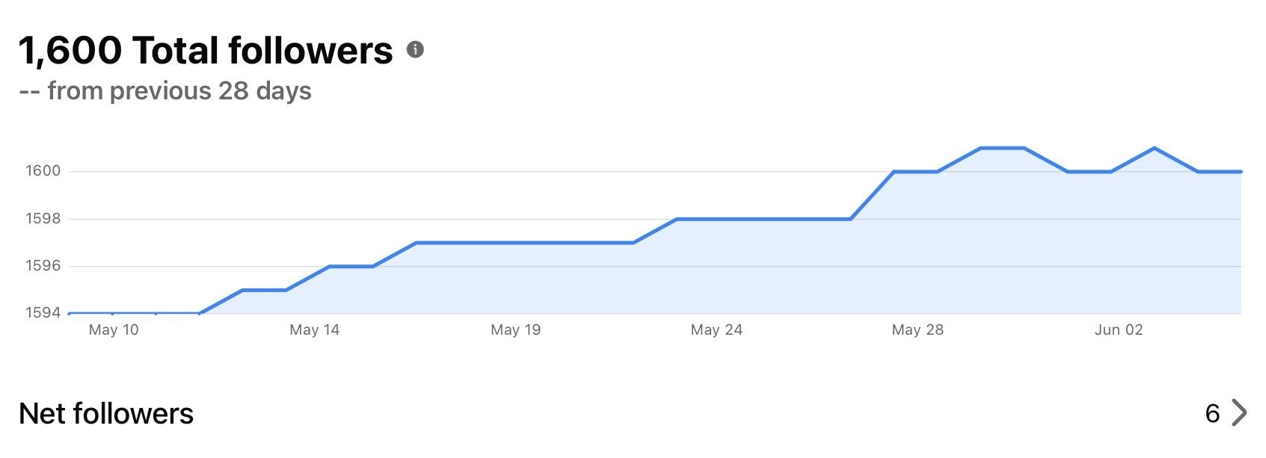
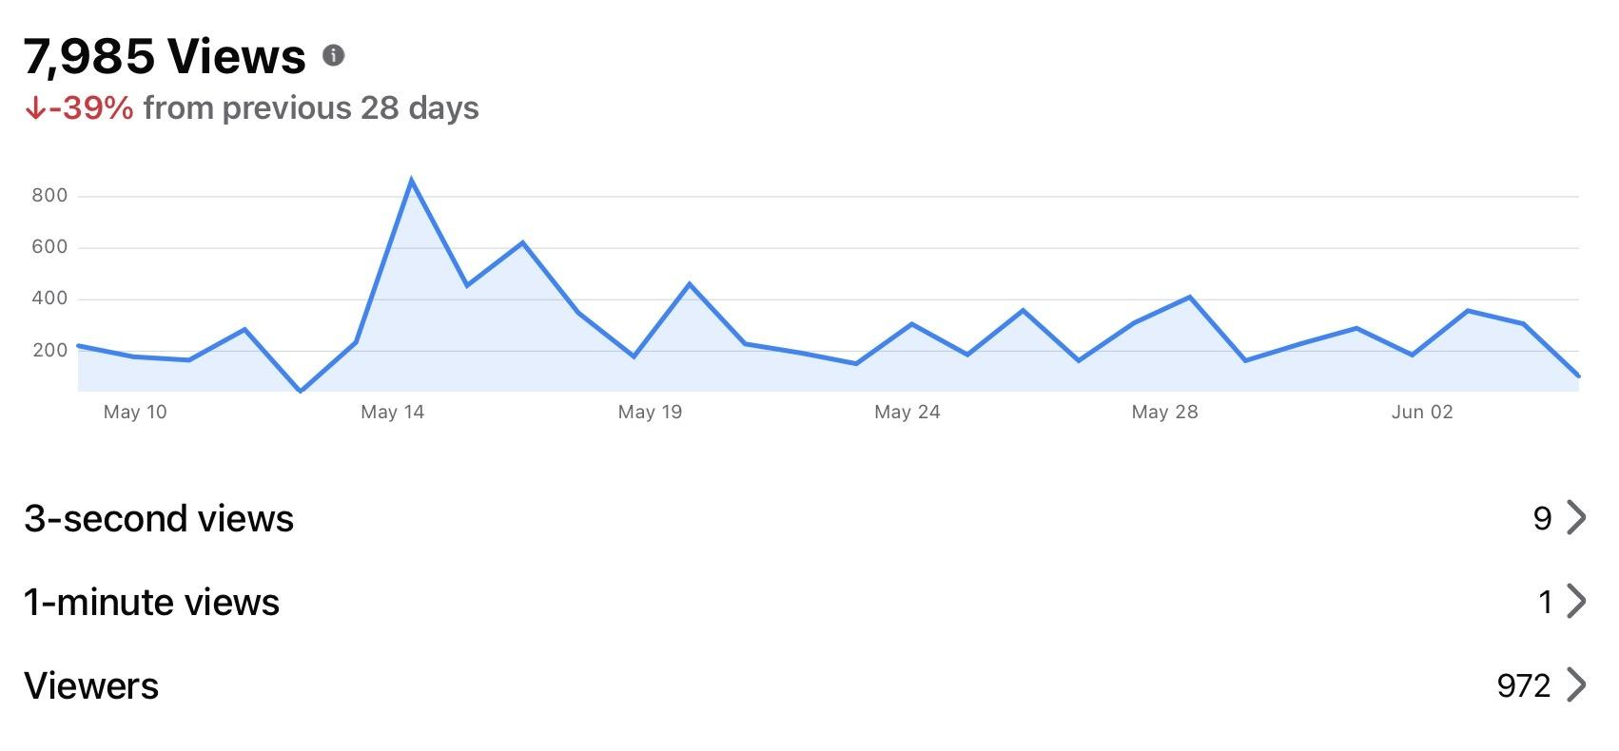

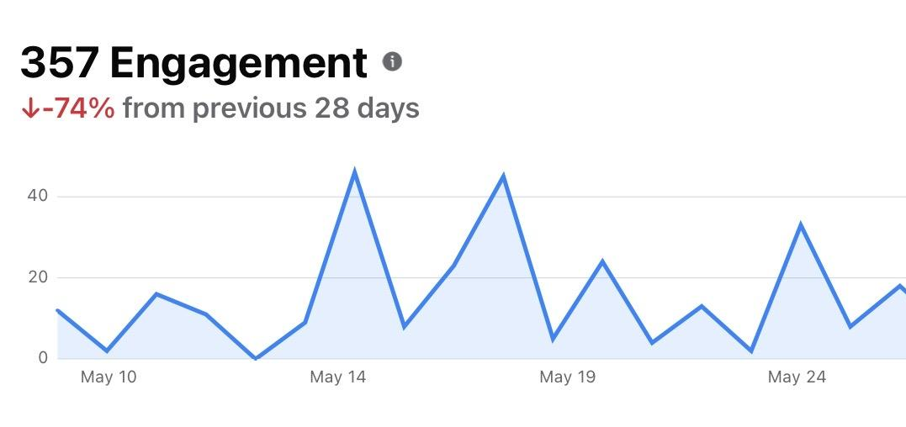
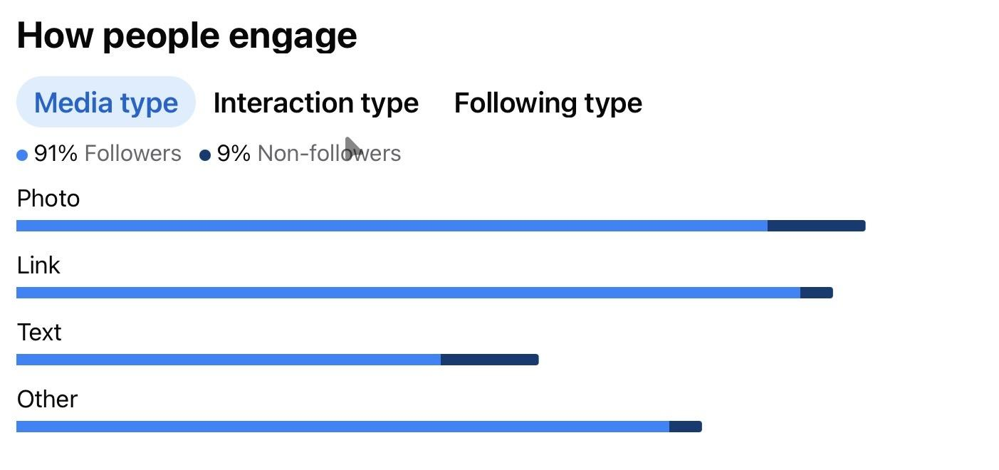
    - Instagram
      - Views -
      - Engagement -
      - Net Followers -
      - Jacob will update to a professional IG account.

    - TikTok
      - Views -
      - Engagement -
      - Net Followers -
      - Locked out, Jacob will try and see if he can get into the accounts.
- Board Action Items
  - N/A

Recruitment Director Reports:
- Informational Items
  - N/A
- Board Action Items
  - N/A

Sponsorship Director Reports:
- Informational Items
  - SINGO at Remedy Brewing
    - $300 cash from SINGO Cards
    - $150 cash from 50:50 Raffle, raised $300, $80 paid Venmo winner took $150
    - $315 Venmo from SINGO Cards
    - Volunteers, Chris Gray, Megan Weston, Beckahh WestraDJ
    - All prizes were donated, no cost
    - Remedy Brewing would like to see this be regular event
      - Will visit with Aaron if wanting just SINGO or fundraiser each time
  - Jasper Stone Air BnB
    - Donated 2 night stay, value of $500
    - Proposed we could silent auction during Sioux Falls Pride @ the SEPSA Booth
    - Can utilize Zeffy,
      - Manny is creating marketing material will need Zeffy QR Code
      - SEPSA Promote via email and social media
    - Place their logo and link on SEPSA Website Sponsorship page
    - Explore the option of adding other items
      - Focus on gift cards, easy to mail and low cost
  - Corn Hole Tournament
    - Jul 25, 2026at Club David from 5-9 pm
    - League App set up for registration and take payment
    - Set up Facebook Event
  - Drag the Fields
    - Sept 19, 2026
    - Club David
    - Doors Open 8 PM, Show starts 9 PM
    - Last year $15 Advance Tickets, $20 at Door
      - Do we want to do same pricing for 2026
    - 50:50 Raffle, confirm to add
    - Silent Auction Metal Drag Queen Michael Fetterer donated, add to event
- Board Action Items
  - N/A

Community Volunteer Director Reports:
- Informational Items
  - Damon is asking if SEPSA Members would be interested in volunteering down at the Banquet. We will put a blast out to our members and use sign up genius to track how many people are interested and willing to volunteer. He will be volunteering on Friday, June 12th, but the possibility of volunteering more in the future.
- Board Action Items
  - N/A

Marketing Director Reports:
- Informational Items
  - Cornhole Tournament Fundraiser, confirm final design
  - Drag the Fields, to be created
- Board Action Items
  - N/A

Standing Committee Reports
Sponsorship, Marketing, & Recruitment Committee
- Informational Items
  - Sioux Falls Parade
  - Taylor Rasmussen decorating float and providing jeep
  - Sioux Falls Pride Vendor Fair
  - Shane & Ty providing the canopy
- Board Action Items
  - N/A

Operations / Events Committee
- Informational Items
  - Sioux Empire Classic
    - Tournament Directors Chris Sorenson, Jacob Grimesand Chris Gray volunteered at NSC
    - Was beneficial for both their Tournament Directors
    - Brian will be providing program to compare iPride Portal Ratings and rating submitted
    - North Star Classic provided a $100 gas card and paid for 2 nights hotel stay for Tournament Directors’ Time
      - This was unexpected and was not asked for
- Board Action Items
  - N/A

Hall of Fame Committee
- Informational Items
  - N/A
- Board Action Items
  - N/A

Executive Board Reports
President’s Report:
- Informational Items
  - Jul 11, 2026Board Meeting
  - Aug 15, 2026 Board Meeting, after tournaments
  - Sept 12, 2026, proposed date, 2 Saturday of month
    - Potentially changing the weeks we host board meetings.
  - Reminder, when wearing SEPSA logo shirts, you are representing SEPSA.
- Board Action Items

    - Motion: Second: Vote:

Vice President’s Report:
- Sunshine Fund Disbursement to Ty King and Shane & Shad & Shaun Pickner for their recent passing of Ty’s father & the Pickner’s Grandmother.

- Board Action Items
  - Motion to order flowers for the Pickner family up to $75. Second: Beckahh Vote: Unanimous
  - Motion for $75 check to help with travel expenses for Ty’s fathers funeral. Second: Beckahh Vote:Unanimously

Treasurer's Report:
- Informational Items
  - Sent out April financials
  - Will be sending out May financials today
  - October 3rd for the banquet?
  - If so, able to reserve Terrace Park West picnic shelter.
    - Hours for banquet needed - max able to reserve is 4 hours (I think)
    - Beckahh will reach out to Izzi’s gym to look at their space.
  - SF Sliders going to GSWS but will be paying SEPSA for deposit via check ??
  - Jacob (and possibly Megan) going to iPride meetings in Columbus, OH in late August - will need to hand out GSA M&IE checks at August board meeting
  - Deposit $20 cash from Beckahh for Katie Hartigan’s volleyball player fee
  - Deposit $370 cash from Singo fundraiser - $315 sent through Venmo
  - Reimburse Chris Sorenson $14.12 for replacement wheel for softball chalking machine
  - Reimburse Jacob Grimes for flights & hotel to Columbus, OH iPride meetings - $1118.13
  - Issue check to Ty King for $75 for the recent loss of his father along with sympathy card
  - Purchase sympathy arrangement for Shane Pickner & family for recent loss of their grandmother
- Board Action Items
  - Motion to approve Treasurer’s Report
    - Motion: Michael Hanson Second: Jacob Vote: Unanimously

Chief Information Officer Report:
- Informational Items
  - Website - Resources
    - It looks like this page hasn’t been updated for some time
    - Any changes needed? Yes, update navigation to “Community Resources” instead of just resources
  - Time to update Executive Officer Election details to 2026 positions?
- Board Action Items
  - N/A
    - Motion: Second: Vote:

Secretary’s Report:
- Informational Items
  - I’ve been reviewing the secretary's duties along with Bylaws, Athletic codes, and grievance policy.
  - Who receives the softball meeting minutes?
    - 6.5.7. Each Committee or Athletic Commissioner MUST hold monthly meetings during their leagues operating months regarding its performance in carrying out league divisional activities and give notice of meetings to all league registered members and registered non-members at least one(1) month in advance. Meeting minutes must be submitted to SEPSA’s Secretary immediately following each meeting to be made available on SEPSA’s website.
    - 6.5.9. Each Committee or Athletic Commissioner MUST file, with SEPSA’s Secretary, a complete monthly report regarding its performance in carrying out divisional activities of SEPSA.
  - Conflict of Interest Policy
    - 2.2 FINANCIAL INTEREST. A person holds a “financial interest” if the person, directly or indirectly, has through business, investment, or family.
      - A financial interest is not necessarily a conflict of interest. Under Paragraph 3.2 below, a person who possesses a financial interest has a conflict of interest only if the appropriate governing board or committee decides a conflict of interest exists.
    - 3.2 DETERMINING WHETHER A CONFLICT OF INTEREST EXISTS. After disclosure of the financial interest and all material facts, and after any discussion with the interested person, he or she will leave the governing board or committee meeting while the determination of a conflict of interest is discussed and voted upon. The remaining board or committee members will decide if a conflict of interest exists.
    - ARTICLE 6 ANNUAL STATEMENTS
      - 6.1 ANNUAL STATEMENTS. Each director, principal officer, and member of a committee with governing board delegated powers will annually sign a statement which affirms each person: (a) Has received a copy of the conflicts of interest policy; (b) Has read and understands the policy; (c) Has agreed to comply with the policy; and (d) Understands the Corporation is charitable and in order to maintain its federal tax exemption it must engage primarily in activities which accomplish one or more of its tax-exempt purposes.
        - Annual_Conflict_of_Interest_Statement.pdf
        - Who do we need to provide this information to still for them to sign?
          - First Meeting in November, this statement will be provided to Board Members to review and sign.
  - Updates to Grievance Policy to make it stronger, clearer, and legally defensible while also protecting the organization and members more consistently.
    - Clarifying Investigation Timelines
      - Right now, the policy says: “The committee provides an initial written response within ten days.” But it does not define:
        - How long investigations may take
        - When parties will receive updates
        - Or when final determination should occur
    - Define “Conflict of Interest” For Committee Members
      - Since the Grievance Committee investigates complaints, you should explicitly state that committee members must recuse themselves if they have:
        - personal involvement,
        - family relationships,
        - financial interest,
        - prior disputes,
        - or bias related to the matter.
    - Add Confidentiality Expectations
      - Currently our policy does not address confidentiality.
        - “All complaints and investigations shall be handled as confidentially as reasonably possible, consistent with conducting a fair and thorough investigation.”
          - This protects both complainants and accused parties.
    - Add Due Process / Fairness Language
      - Right now the accused party’s rights are somewhat unclear. Let's add or state;
        - right to respond,
        - opportunity to present evidence,
        - impartial review,
        - written findings.
        - “Individuals accused of violating the Code of Conduct shall be given notice of the allegations and an opportunity to respond before disciplinary action is finalized, unless immediate suspension is necessary to protect the safety or welfare of participants.”
          - This becomes important if discipline is challenged later.
    - Clarify Standard for Emergency Suspension
      - “if circumstances warrant,” - This is a broad statement. Can we tighten it by adding;
        - “SEPSA reserves the right to impose temporary suspension pending investigation where credible allegations involve safety risks, harassment, discrimination, retaliation, violence, or conduct that may threaten the welfare of participants or the organization.”
    - Add Appeal Process
      - We don’t have an appeal process?
        - Add- who can appeal,
        - deadline to appeal,
        - who hears appeals,
        - whether the decision is final.
        - “Any party subject to disciplinary action may submit a written appeal to the Board of Directors within fourteen (14) days of receiving the final determination.”
    - Clarify Anonymous Complaints
      - Right now it doesn’t say whether anonymous complaints are accepted. Considering we now know that someone wanted to remain anonymous but we were not made aware of we definitely need to cover this.
        - Add- “Anonymous complaints may be reviewed; however, SEPSA’s ability to investigate and respond may be limited when insufficient information is provided.”
    - Define Record Retention
      - It’s wise to state how complaints and investigations are documented.
        - Add- “Records relating to complaints, investigations, findings, and disciplinary actions shall be maintained securely by SEPSA in accordance with organizational record retention practices.”
    - Consider Narrowing Some Language
      - A few sections may unintentionally create risk because they are extremely broad or subjective, particularly:
        - “maliciously false statements”
        - “using institutional or political power maliciously”
        - “social media posts”
        - “physical appearance”
          - Broad language can sometimes be interpreted inconsistently.
            - Add- “as determined by the Grievance Committee based on objective evidence and the totality of circumstances.”
            - That gives more procedural protection.
    - Digital Communication / Online Conduct Standards
      - We mention Social media but can we include:
        - group chats,
        - Texting,
        - Email,
        - Livestreams,
        - online gaming/voice chats,
        - private messaging.
          - Add- “This policy applies to conduct occurring in person, online, through social media, electronic communications, messaging platforms, and other digital interactions connected to SEPSA activities.”
    - Governance Recommendation
      - Add-
        - annual acknowledgment forms,
        - annual conflict of interest disclosures,
        - and a non-discrimination statement approved annually by the board.
          - These are helpful for nonprofit governance and insurance purposes.
- Set Board Meeting date to go over All of SEPSA policies to amend.
  - Conflict of Interest Policy
    - By briefly looking over it I’ve determined that we could make it stronger and better align with best practices and IRS expectations.
      - Expand Conflict of Interest Definition
      - Clarify Recusal Procedures
      - Confidientality Expectations
      - Whistleblower/Retaliation Protection Reference
      - Policy Review Requirement
  - SEPSA Bylaws
    - Conflict of Interest Policy and Bylaws are not tied together
      - 9.3 We reference Conflict of Interest but the Bylaws should also state
        - disclosures are mandatory,
        - recusals are required,
        - and violations may result in discipline or removal.
      - If prioritizing, I would focus first on:
        - Conflict of interest enforcement
        - Removal procedures and due process
        - Meeting/electronic voting procedures
        - Confidentiality and executive session rules
        - Clarifying board/member authority
        - Committee authority limitations
        - Appeals and disciplinary procedures
        - Attendance requirements
        - Digital governance updates
        - Cross-referencing grievance and ethics policies
    - Recommended Order of Revision
      - To avoid conflicts, update documents in this order:
- Bylaws
- Conflict of Interest Policy
- Grievance Procedure & Policy (5/9/2026)
- Annual Forms & Acknowledgments
- Board Procedures / Operating Guidelines

- Board Action Items

    - Motion :AMEND THE GRIEVANCE PROCEDURE AND POLICY
      - Beckahh moves that the Board approve amendments to the SEPSA Grievance Procedure and Policy to strengthen governance, procedural fairness, confidentiality, conflict of interest standards, and investigation procedures.
      - The proposed amendments shall include, but not be limited to:
        - (a) Establishing clearer timelines for investigations, responses, and determinations;
        - (b) Adding conflict of interest and recusal requirements for Grievance Committee members and board participants involved in complaint reviews;
        - (c) Clarifying confidentiality expectations during grievance investigations and proceedings;
        - (d) Providing due process protections, including notice of allegations and an opportunity for responding parties to provide information before final disciplinary action is taken;
        - (e) Clarifying standards and procedures for temporary suspensions or emergency actions pending investigation;
        - (f) Establishing an appeal process for disciplinary determinations;
        - (g) Clarifying procedures regarding anonymous complaints and record retention practices;
        - (h) Expanding policy applicability to include electronic communications, social media, messaging platforms, and other digital conduct related to SEPSA activities;
        - (i) Revising and clarifying policy language to support consistent, objective, and fair enforcement of standards; and
        - (j) Authorizing the Board, Grievance Committee, or designated officers to make any non-substantive formatting, grammatical, or administrative revisions necessary to finalize the amended policy.
        - If any member feels they have a grievance, the Board of Directors fully encourages them to bring the issues to the grievance committee. Before formally filing a grievance, we respectfully request that members first consider the following:
- Contact your Team Manager – Any issues with a teammate, we encourage members to take their concerns to the team manager.
- Contact your League Commissioner – If issues can’t be resolved within the team, or if the issues are with another team.
- Contact the Grievance Committee – If the above methods of resolution have not been successful – OR – if the member feels uncomfortable taking the above steps.
      - These amendments shall become effective upon approval by the Board unless otherwise specified.
    - Motion: Michael Hanson Second: Cari Vote: Unanimously
- Create a Bylaw update committee with executive board members
    - Motion: Beckahh Second: Michael Vote: Unanimously
- Formal complaint about Softball Commissioner addressed regarding lack of responsibility and financial accountability and investigation is pending
- Approve May Meeting Minutes
  - Motion: Cari Second: Michael Vote:Unanimously

Grievance Committee
- Discussed Key Outcomes 6/5/26 Pre-Board Meeting Notes
- Board Action Item
  - Creating a single email for the grievance committee to share

    - : Beckahh Second: Cari Vote: UnMotionanimously

Adjournment: 3:08pm
Motion: Michael Second: Cari Vote: Unanimously

Notes & Reminders:
Please submit additions and changes by Thursday before the meeting

Next Meeting: (07/11/2026) | Location: SF Library

Website: www.siouxempirepsa.org  Registration: www.siouxempirepsa.leageapps.com | MAILING ADDRESS  PO BOX 88657  SIOUX FALLS, SD 57109
Email: info  Google Drive: admin | “PHYSICAL” ADDRESS  2501 S LOUISE AVE UNIT 88657  SIOUX FALLS, SD 57109

